__________________________________________________________________________________________

PRODUCT DESCRIPTION

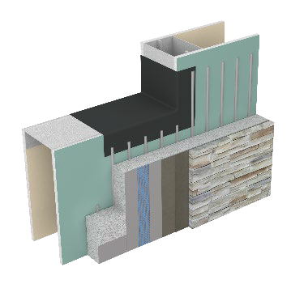Dryvit offers a family of performance-based systems that allows architects and owners to meet the   
specific demands of today’s energy codes, such as continuous insulation and an air/water-resistive   
barrier. Dryvit’s original Outsulation System has been installed on over 500,000 buildings worldwide.   
Due to the increased demands for a wall system to be able to drain away incidental moisture, the   
Outsulation concept has grown into a family of related systems, each building upon the other to   
achieve specific performance goals.

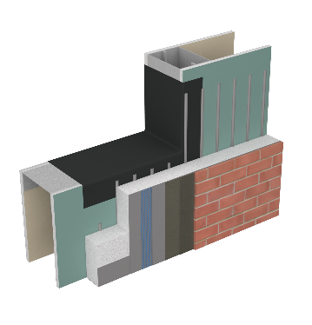

____________________________________________________________________

FEATURES & BENEFITS

* High-Performance EIF System with Moisture Drainage
* Air/Water-Resistive Barrier
* Continuous Insulation (CI)
* Increased Durability and Impact Resistance
* NFPA 285 Fire Testing Compliant
* Masonry Veneer Finish

__________________________________________________________________________________________

SYSTEM COMPONENTS

1.Dryvit Backstop NTX Air/Water-Resistive Barrier and Accessory Components

2.Dryvit/Tremco Flashing System

3.Dryvit Drainage Components and/or Pre-Based Starter Board

4.Dryvit Primus® Adhesive for EPS Insulation in vertical notched trowel configuration

5.EPS Insulation Boards, creating a layer of continuous insulation

6.Dryvit Reinforced Base Coat – Intermediate Mesh Only

7. Dryvit Modified Primus Skim Coat for substrate preparation

8.Dryvit Modified Primus for adhesion of the masonry veneer

9.Manufactured Stone Masonry Veneer Compliant with Acceptance Criteria AC51 or Thin Veneer Brick demonstrating compliance with ASTM C1088

10.Mortar for Joint Treatment compliant with masonry veneer manufacturer’s requirements (as applicable)

__________________________________________________________________________________________

SYSTEM OVERVIEW

Outsulation Masonry Veneer System (OMVS) expands upon the proven weatherability and insulating qualities of Outsulation by adding a second line of defense against air, moisture, and weather. This is accomplished with Dryvit Backstop NTX Air/Water-Resistive Barrier, accessory components and flashing system. Outsulation MVS goes one step further through the use of Dryvit Primus adhesive channels in a vertical notched trowel pattern to provide moisture drainage as well as Modified Primus for the Skim Coat and the adhesive for the selected masonry veneer.

__________________________________________________________________________________________

LIMITATIONS

1. Manufactured Stone Masonry Veneer materials are precast concrete products made to resemble natural stone or brick and used as adhered, non-load-bearing exterior veneers on wood or light gauge steel stud framing, concrete or concrete masonry walls.
2. Manufactured Stone Masonry Veneer Units shall be recognized in a current ICC ES Evaluation Report demonstrating compliance with ICC-ES AC51 Acceptance Criteria for Adhered Manufactured Stone Masonry and ASTM C1670 Standard Specification for Adhered Manufactured Stone Masonry Units.
3. Thin veneer brick units are made from clay, shale, fire clay, sand, or mixtures thereof, are fired ,and used in adhered veneer applications.
4. Thin Veneer Brick units shall demonstrate compliance with ASTM C1088 Standard Specification for Thin Veneer Brick Units Made From Clay or Shale
5. The masonry veneer materials shall develop a shear bond strength between the Substrate, Skim Coat Substrate Preparation, selected masonry veneer units and the Dryvit Modified Primus Adhesive of not less than 50 psi (350 kPa) when tested in accordance with Test Method ASTM C482.
6. The average saturated veneer and mortar weight combined shall not exceed 15 pounds per square foot (73.2 kg.m²).
7. Installation shall comply with the selected masonry veneer manufacturer’s current ICC-ES report (for Manufactured Stone Masonry Veneer), published installation instructions – excluding adhesive / adhesion, Outsulation MVS application instructions DS976 and the applicable code.
8. Expansion or control joints used to limit the effect of differential movement of supports must be specified by the architect, designer or masonry veneer manufacturer. Consideration must also be given to movement caused by temperature change, shrinkage, creep and deflection.
9. The supporting wall assembly to which the masonry veneer is adhered shall be designed to support the installed weight of the veneer system, including veneer, veneer adhesive and mortar. The supporting wall assembly shall be structurally engineered to limit deflection to 1/360 of the span and primary framing members at rough openings / wall penetrations shall be structurally engineered to limit deflection to 1/600 of the span under design wind loads.
10. Allowable plan radius geometry is directly dependent to the relationship of the plan radius to width of the selected veneer unit to maintain proper adhesive thickness and overall adhesion contact to the substrate. For radius applications, consult with Dryvit Technical Services at 800-556-7752.
11. For use in Freeze/Thaw Climate Zones, some masonry veneer materials may not be suitable, or the selected manufacturer may have other restrictions that apply. Consult with selected masonry veneer material manufacturer for guidance regarding appropriateness, testing, and history of use in freeze/thaw climate zones.
12. Open mortar joint construction increases risk of water infiltration behind the Manufactured Stone Masonry Veneer and/or wall assembly, increased efflorescence, and freeze/thaw damage. Consult with selected Manufactured Stone Masonry Veneer materials manufacturer and incorporate proper design and detailing to reduce risk.
13. Consult with selected masonry veneer materials manufacturer for proper design of mortar joints, where applicable.
14. Maximum allowable height above grade shall be specifically determined by the architect, designer, or masonry veneer manufacturer in accordance with published wind load data.
15. Maximum allowable average thickness of each Manufactured Stone Masonry Veneer unit shall be less than or equal to 2-5/8” (67 mm) and minimum thickness shall be 1/4" (6 mm) except those parts of a unit within 0.5 in (13 mm) of the unit perimeter, in accordance ASTM C1670.
16. The thickness of the Thin Veneer Brick Unit shall not exceed 1 3⁄4 in. (44.45 mm), in accordance with ASTM C1088.
17. Individual veneer units shall not exceed 36” (915 mm) in any face dimension and shall not exceed more than 5 sq ft (0.5 m²) in total face area. Maximum sized veneer units may require supplemental bracing or support during adhesive curing.
18. Maximum joint spacing shall be based on 18 ft for any one dimension and 144 sq ft for total wall area. Maintain an aspect ratio of joint layout at 1 to 2-1/2 or less.
19. For Direct applied over cement board substrates, the following additional limitations shall apply:
    1. Wall and cement board assembly shall be based on Dryvit Cement Board Moisture Drainage (CBMD). Refer to Dryvit CBMD Details DS190 and Specifications DS191 for reference and coordination. Alternative direct applied to cement board substrate wall assemblies shall be evaluated on a case-by -case basis. Consult with Dryvit Technical Services at 800-556-7752.
    2. Architect or Designer shall be solely responsible for all design and detailing associated with incorporation of selected masonry veneer over Dryvit CBMD wall assembly such as but not limited to proper edge termination, wall penetration, component integration, flashing integration and sealant joint development.
    3. Masonry veneer over Dryvit CBMD shall be limited to a maximum of 20 ft in height.
    4. Masonry veneer over Dryvit CBMD shall be limited to locations / climate zones which do not experience freeze thaw cycling as determined by the architect, designer, or masonry veneer manufacturer.
    5. Minor cracking is possible in the finished exterior surface.
    6. Base coat material shall not be used to level wall surface imperfections.
    7. Dryvit Intermediate Reinforcing Mesh must be used.

Information contained in this product sheet conforms to the standard detail recommendations and specifications for the installation of Dryvit products as of the date of publication of this document and is presented in good faith. Dryvit assumes no liability, expressed or implied, as to the architecture, engineering or workmanship of any project. To ensure that you are using the latest, most complete information, contact Dryvit.

For more information on Dryvit or Continuous Insulation, click here.

Printed in USA. Issued 11.7.2023 ©Dryvit 2023

DS975